Creating a Pod with nginx image tag 1.14.2, and run on port 80

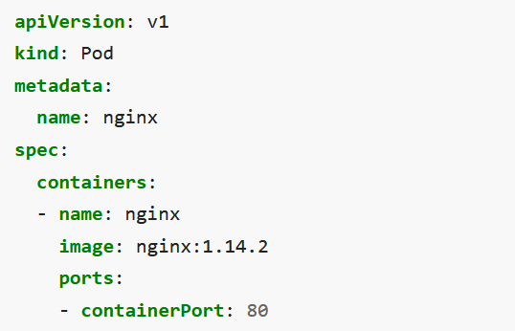

Link: <https://kubernetes.io/docs/concepts/workloads/pods/>

What is Pod Template Controllers for [workload](https://kubernetes.io/docs/concepts/workloads/) resources create Pods from a pod template and manage those Pods on your behalf. PodTemplates are specifications for creating Pods, and are included in workload resources such as [Deployments](https://kubernetes.io/docs/concepts/workloads/controllers/deployment/), [Jobs](https://kubernetes.io/docs/concepts/workloads/controllers/job/), and [DaemonSets](https://kubernetes.io/docs/concepts/workloads/controllers/daemonset/).

Replicaset vs Deploymentset A ReplicaSet ensures that a specified number of pod replicas are running at any given time. However, a Deployment is a higher-level concept that manages ReplicaSets and provides declarative updates to Pods along with a lot of other useful features.

Minimum ready seconds .spec.minReadySeconds is an optional field that specifies the minimum number of seconds for which a newly created Pod should be running and ready without any of its containers crashing, for it to be considered available.

How we can see pod specification? Kubectl describe pod <pod-name>

Produce imagepullerror and fix it? Update nginx image as nginx:2020ht66049 and run kubectl apply command

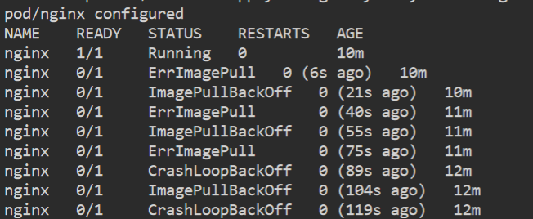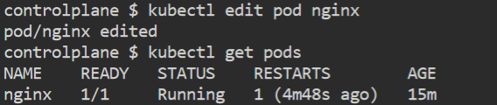

CrashLoopBackOff is not an error in itself but indicates that there's an error happening that prevents a Pod from starting correctly.

If something prevents the container runtime from pulling an image onto the node that Kubernetes has [scheduled](https://kubernetes.io/docs/concepts/scheduling-eviction/kube-scheduler/) your Pod onto, the kubelet will report back ErrImagePull, then ImagePullBackOff, and keep trying.

When we are writing pod specification by default kubectl add other parameters with default value. [kubectl is a tool that convert yamls file into API call]

How to check logs of pods kubectl -n <namespace> pods podname

What are events in k8s Kubernetes events are a resource type in Kubernetes that are automatically created when other resources have state changes, errors, or other messages that should be broadcast to the system. While there is not a lot of documentation available for events, they are an invaluable resource when debugging issues in your Kubernetes cluster.

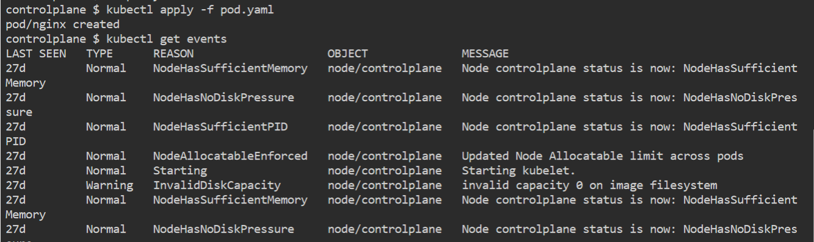

why should i use k8s? For container management

What are stateful sets? To manage stateful application we have statefulset

What is purpose of headless service? To access pod directly. [Generally, in case of stateful set]

What is CSI? 1) When container started, everyone wanted to move to container, but initially it was primarily for stateless application, and slowly it started working towards statefull application.

2) When we want to move statefull application to Kubernetes we need to write our own method to manage storage system.

2) When People want move their stateful application into Kubernetes, and vender needs to write custom plugin to manage storage for each provider, and even they need to update code in Kubernetes, and they need to wait for release.

to shoutout this Gap Docker, Google and Mesosphere come together, and decided model for storage driver and their extension.

What is CNI [Kubernetes networking interface] ? K8s dictates the following requirements on any networking implementation

* All Pods can communicate with all other Pods without using NAT (network address
* translation)
* All Nodes can communicate with all Pods without NAT
* The IP that Pod sees itself is the same IP that others see it as

What is the last problem which you faced in k8s? Error: Can’t use the name is still in use

How to use external vault in k8s Vault running external of a Kubernetes cluster can be addressed by any of its pods as long as the Vault server is network addressable. Link: <https://developer.hashicorp.com/vault/tutorials/kubernetes/kubernetes-external-vault>

How to backup k8s cluster? Some thirdparty tools like K10 available for doing that.

How to upgrade the k8s cluster? Some manual commands needs to be run Link: <https://kubernetes.io/docs/tasks/administer-cluster/kubeadm/kubeadm-upgrade/>

what is draining the node vs cordon the node? It’s Kubernetes maintenance activity for node.

Can we implement custom dns in k8s? Yes, By default we are using coreDns but we can customize it

What is default dns in k8s? coreDns

communication between two services in different namespaces Servicemesh

How to auto scale nodes in aks/eks? cluster node autoscaler Nodeautoscaller, pod autos caller

List down atleast 10 most common k8s failures? Imagepullbackoff, containercrashloopbackoff, backofflimitexceeded, releasenotfound, name is still in use,Cotainercreateconfigerror.